|  |
| --- |
| PRACTICAL - 6 |

**AIM : Write a program to perform clustering on given product data base using (a) k-mean clustering (b) Hierarchal clustering (c) DBSCAN compare the accuracy of all these three approaches.(**[**https://archive.ics.uci.edu/dataset/837/product+classification+and+clustering**](https://archive.ics.uci.edu/dataset/837/product+classification+and+clustering)**)**

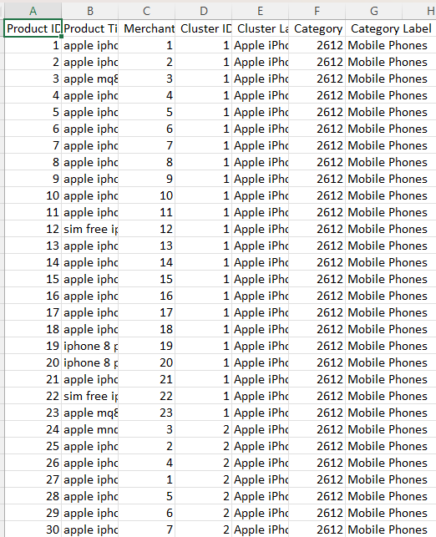

|  |
| --- |
| import pandas as pd  import numpy as np  import matplotlib.pyplot as plt  import seaborn as sns  from sklearn.preprocessing import StandardScaler  from sklearn.cluster import KMeans, AgglomerativeClustering, DBSCAN  from sklearn.metrics import adjusted_rand_score, silhouette_score    from google.colab import files  uploaded = files.upload()    file_path = "pricerunner_aggregate.csv"  df = pd.read_csv(file_path)    df.columns = df.columns.str.strip()    X = df[['Merchant ID', 'Category ID']]    scaler = StandardScaler()  X_scaled = scaler.fit_transform(X)    true_labels = df['Cluster ID'].values    inertia = []  k_values = range(2, 15)    for k in k_values:      kmeans = KMeans(n_clusters=k, random_state=42, n_init=10)      kmeans.fit(X_scaled)      inertia.append(kmeans.inertia_)    plt.figure(figsize=(8, 5))  plt.plot(k_values, inertia, marker='o', linestyle='--', color='b')  plt.xlabel('Number of Clusters (K)')  plt.ylabel('Inertia')  plt.title('Elbow Method for Optimal K')  plt.show()    optimal_k = 6    kmeans = KMeans(n_clusters=optimal_k, random_state=42, n_init=10)  kmeans_labels = kmeans.fit_predict(X_scaled)    hierarchical = AgglomerativeClustering(n_clusters=optimal_k)  hierarchical_labels = hierarchical.fit_predict(X_scaled)    dbscan = DBSCAN(eps=0.5, min_samples=5)  dbscan_labels = dbscan.fit_predict(X_scaled)    ari_kmeans = adjusted_rand_score(true_labels, kmeans_labels)  ari_hierarchical = adjusted_rand_score(true_labels, hierarchical_labels)  ari_dbscan = adjusted_rand_score(true_labels, dbscan_labels)    silhouette_kmeans = silhouette_score(X_scaled, kmeans_labels)  silhouette_hierarchical = silhouette_score(X_scaled, hierarchical_labels)    if len(set(dbscan_labels)) > 1:        silhouette_dbscan = silhouette_score(X_scaled, dbscan_labels)  else:      silhouette_dbscan = -1    print(f"K-Means ARI: {ari_kmeans:.4f}, Silhouette: {silhouette_kmeans:.4f}")  print(f"Hierarchical ARI: {ari_hierarchical:.4f}, Silhouette: {silhouette_hierarchical:.4f}")  print(f"DBSCAN ARI: {ari_dbscan:.4f}, Silhouette: {silhouette_dbscan:.4f}")    plt.figure(figsize=(8, 6))  sns.scatterplot(x=X_scaled[:, 0], y=X_scaled[:, 1], hue=kmeans_labels, palette="viridis", alpha=0.7)  plt.title("K-Means Clustering Results")  plt.xlabel("Merchant ID (scaled)")  plt.ylabel("Category ID (scaled)")  plt.legend(title="Cluster", loc="best")  plt.show()    plt.figure(figsize=(8, 6))  sns.scatterplot(x=X_scaled[:, 0], y=X_scaled[:, 1], hue=hierarchical_labels, palette="coolwarm", alpha=0.7)  plt.title("Hierarchical Clustering Results")  plt.xlabel("Merchant ID (scaled)")  plt.ylabel("Category ID (scaled)")  plt.legend(title="Cluster", loc="best")  plt.show()    plt.figure(figsize=(8, 6))  sns.scatterplot(x=X_scaled[:, 0], y=X_scaled[:, 1], hue=dbscan_labels, palette="Set1", alpha=0.7)  plt.title("DBSCAN Clustering Results")  plt.xlabel("Merchant ID (scaled)")  plt.ylabel("Category ID (scaled)")  plt.legend(title="Cluster", loc="best")  plt.show()  accuracy_df = pd.DataFrame({      "Clustering Algorithm": ["K-Means", "Hierarchical", "DBSCAN"],      "Adjusted Rand Index (ARI)": [ari_kmeans, ari_hierarchical, ari_dbscan],      "Silhouette Score": [silhouette_kmeans, silhouette_hierarchical, silhouette_dbscan]  })    print("\n### Clustering Performance Comparison ###\n")  print(accuracy_df)    plt.figure(figsize=(10, 5))  accuracy_df.set_index("Clustering Algorithm").plot(kind="bar", colormap="viridis", figsize=(10, 5))  plt.title("Comparison of Clustering Methods")  plt.ylabel("Score")  plt.xticks(rotation=0)  plt.legend(title="Metrics")  plt.show()    best_ari = accuracy_df.iloc[accuracy_df['Adjusted Rand Index (ARI)'].idxmax()]  best_silhouette = accuracy_df.iloc[accuracy_df['Silhouette Score'].idxmax()]    print("\n### Best Clustering Approach Based on ARI ###")  print(f"{best_ari['Clustering Algorithm']} with ARI: {best_ari['Adjusted Rand Index (ARI)']:.4f}")    print("\n### Best Clustering Approach Based on Silhouette Score ###")  print(f"{best_silhouette['Clustering Algorithm']} with Silhouette Score: {best_silhouette['Silhouette Score']:.4f}") |

OUTPUT :

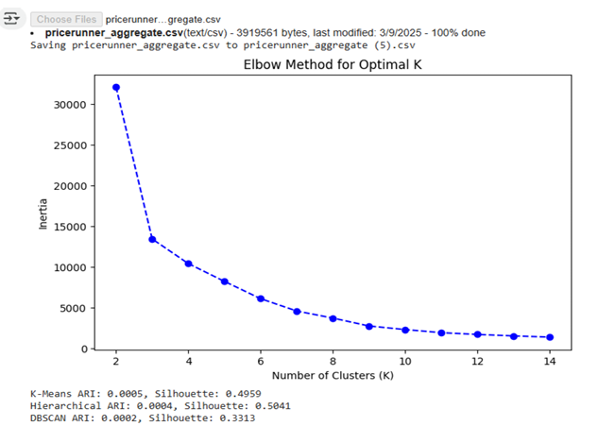

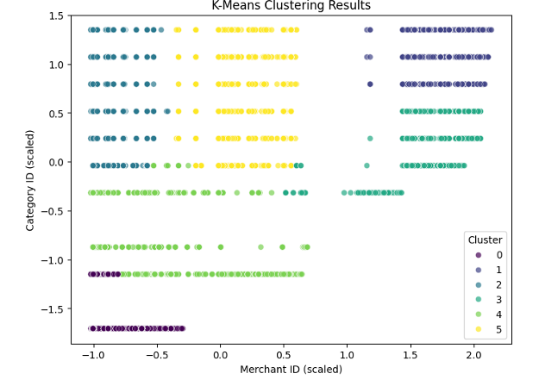

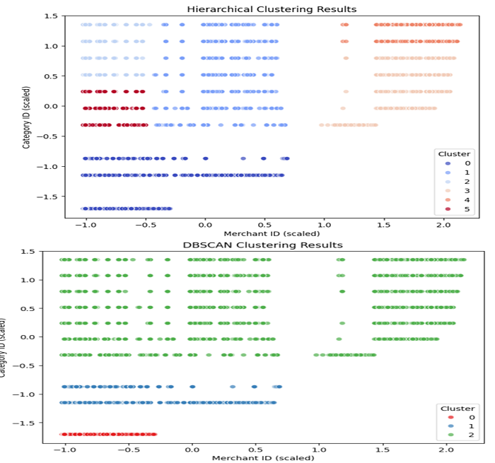

6

